**BIRT Data Extraction Plug-in for**

**MongoDB**



**User Guide for**

**MongoDB Data extraction Plug-in**

**Author: Chandra Mohan N**

**Date : 26-04-2013**

# Contents

Version 3

1. Introduction 4

a. BIRT 4

b. MongoDB 4

c. MongoDB Data Extraction Plug-in 4

2. Plug-in & dependency 4

3. Prerequisites 4

4. Where can this Plug-in be used? 4

5. Using the Plug-in 5

6. MongoDB Server configuration 7

7. Report in Web Viewer 8

8. Export Data 9

9. Viewing the Output 11

10. Enhancement 12

11. Troubleshooting 12

# Version

**Date** : 26-04-2013

**Version** : 1.0.0

**Release** : MongoDB Data Extraction Plug-in for BIRT

**Comments**: Initial version.

# Introduction

## BIRT

BIRT is an open source Eclipse-based reporting system that integrates with your Java/Java EE application to produce compelling reports. BIRT provides core reporting features such as report layout, data access and scripting.

## MongoDB

MongoDB (from "hu**mongo**us") is an [open source](http://www.mongodb.org/about/source-code/) document database, and the [leading NoSQL database](http://www.10gen.com/leading-nosql-database).

## MongoDB Data Extraction Plug-in

BIRT Report Engine provides a data extraction extension point that supports developing a new plug-in for exporting report data to a custom format. The BIRT user interface also provides a built-in data extraction feature that can export data from a report document in CSV format, this functionality is

available in the BIRT Web Viewer. The Data Export feature is available in the BIRT Web Viewer toolbar.

This Data Export feature is extended to support Data extraction directly onto the MongoDb as well as json export file which can be used to dump into MongoDB for later use.

# Plug-in & dependency

MongoDb Data extraction plug-in is available at the project site **org.eclipse.birt.report.engine.dataextraction.mongodb_1.0.0.0.jar**, this plug-in has a dependency on MongoDB java driver for connecting to MongoDB server, Download **mongo-java-driver-2.10.1.jar** And add it to the plug-in folder of eclipse to resolve the dependency

# Prerequisites

Data Extraction plug-in requires the following details to connect to MongoDB, namely

Database Server address: “localhost”(default)

Port Number: 27017(default)

# Where can this Plug-in be used?

This plug-in is useful when you wanted to Export any report data (new/existing reports) directly into MongoDB, the user has a option to select any columns he wants to replicated to MongoDB

This also comes useful when we have multiple types of Datasources used in a report and all the transformed data that report generates can be stored & viewd in a single Mongodb repository

Which may be later used as a Datasource for other report generation tool

Assuming the Initial setup for BIRT and MongoDB is done in the same host, let’s start using the plug-in

# Using the Plug-in

Below is the sample Report Design called HRT.rptdesign done using the sample DataSource with Customer and Orders Data Set. Customer details are shown as a single entry field and all the order details linked to the customer is shown as a table data

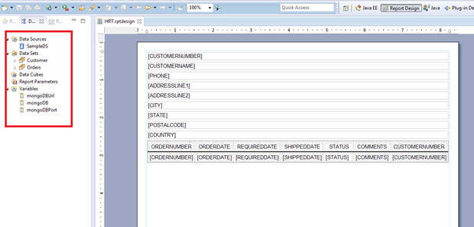

The preview for the HRT report is shown below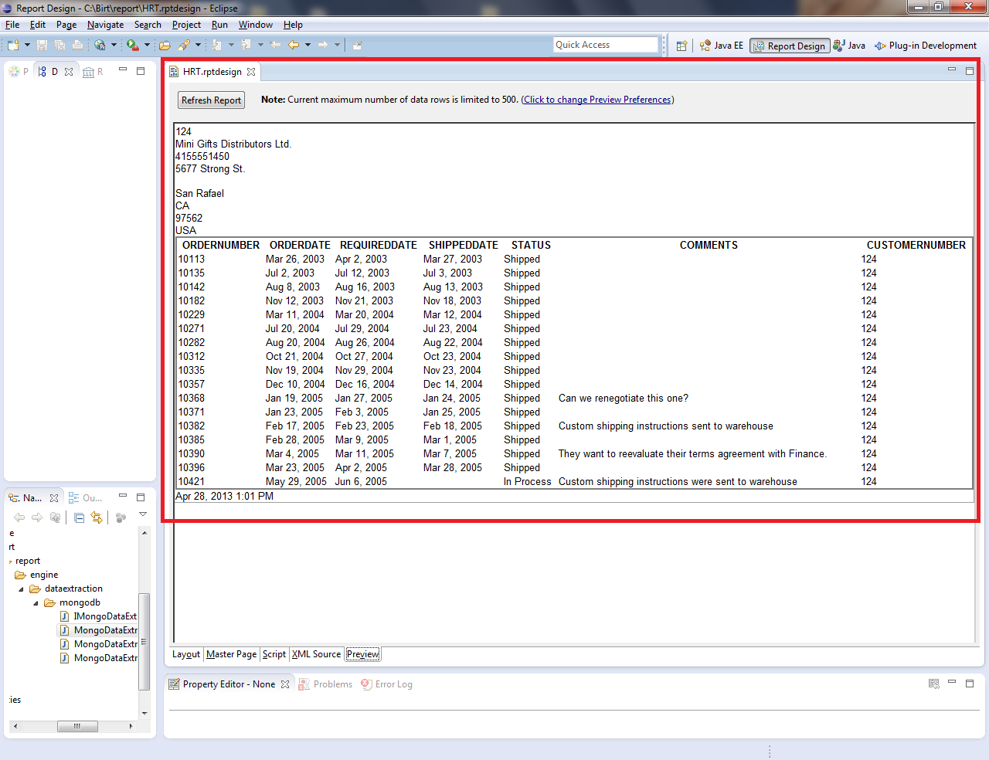

# MongoDB Server configuration

The MongoDB server address and port can be captured by defining a Report Variable in the report Design as shown below. **These Variables are not mandatory if the mongodb is running on the default config** as shown below.

**mongoDBUrl :”localhost”**

**mongoDBPort:”27017”**

**mongoDB**: variable is an optional variable if the user wants to change the

Default Report name as the Database name (ex: **HRT** in the above case).

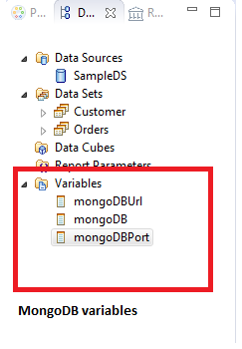 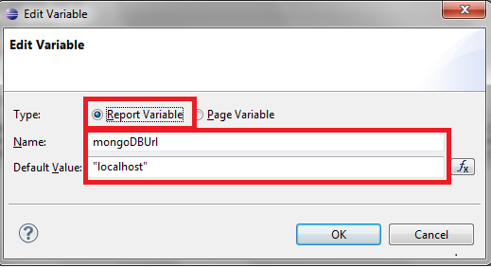

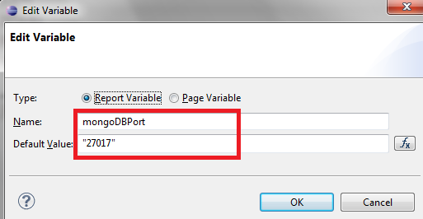

# Report in Web Viewer

Once the report design is completed go to view Report option as shown below

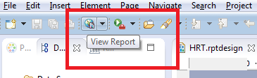

And select view Report in Web Viewer option

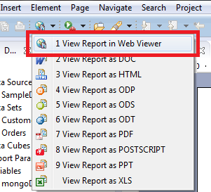

Once the Report Viewer is loaded ,use the Export data as show below

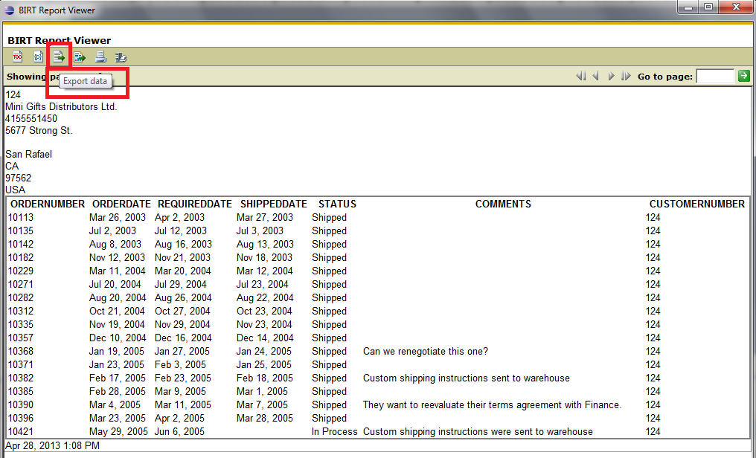

# Export Data

On click of Export Data button,Export Data screen is rendered ,

Select the Result Set which you want to export to mongoDB ,also select the columns that is needed to be exported .

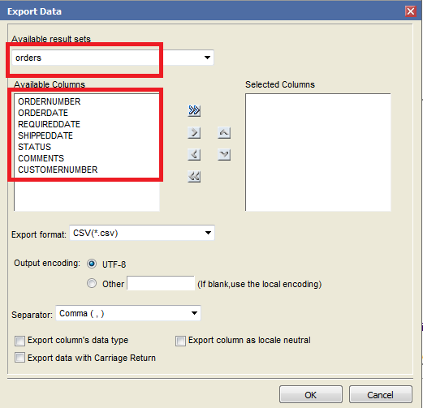

**Note: mongoDB collection name would be the result set name that is selected from the dropdown menu** (This dropdown value is picked from the **“Name”** field of the **General tab** as shown)

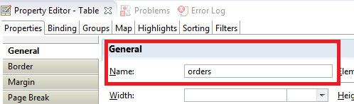

Figure

Select the export(*json) to export the data to mongoDB as well as generate the json file for future updates.

Since mongo doesn’t have support for locale for now, checkbox below has no effect

Similarly the other checkboxes are obsolete in this context.

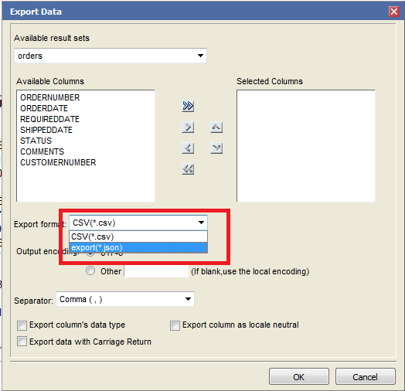

Finally click ok, to execute .

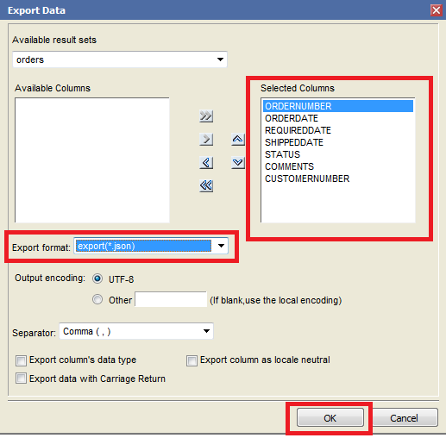

# Viewing the Output

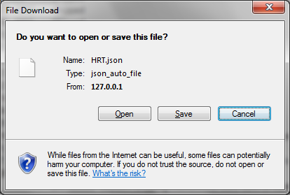

To verify the above export, let’s login to mongoDB using the mongoshell execute the commands given Mongolog.txt is the mongoshell output.



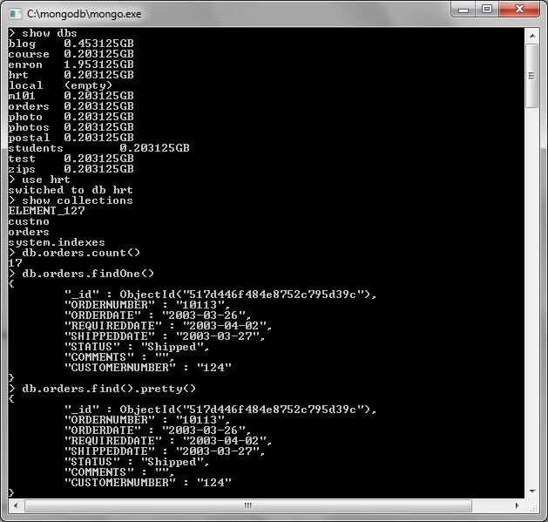

# Enhancement

UI for Configuring the MongoDB: Current implementation mandates the user to configure the MongoDB url and port in the report as a report variable ,Future enhancements can be made such that those parameters are captured in the Export Data screen itself from the user or by using a config file to upload the settings

Perform all CRUD operation from UI: Currently the plug-in is configured for a drop/Load strategy ,Future enhancements can be made in the Export Data Screen UI to have check boxes to capture to different loading strategy like save,FindAndModify,Upsert,Multi-update etc from the user

Performance: For high performance MongoDB can be run the sharded environment, details for sharding can be captured from a config file.

# Troubleshooting

Mongo server not available

* mongoexception would be thrown is the server is not available for getDBcollection
* UnknownHostException would be thrown if the addressed server is down or if there are any network failure

Below is the sample log of one such case

